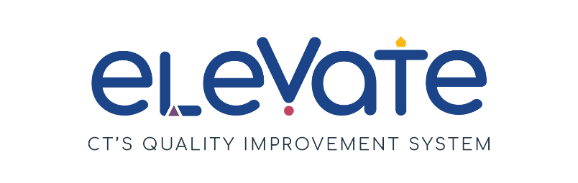
Build Your Team: Professional Growth Checklist
Use this checklist to evaluate professional growth in your program. For each item, place a check in the column that applies. Use “We’ve got this!” for items that are working well. Use “This is a work in progress” for your growth areas. After you complete the checklist, think about how your responses might point you to a place to start your quality improvement work.

 | We’ve got this! | This is a work in progress
My staff understand the job descriptions for their role.
All of my staff members are
enrolled in the Registry.
My staff participate in the process of planning their own professional learning.
My staff know how to find higher education coursework.
My staff know how to find OEC
scholarships to support
higher education coursework.
My staff know how to find resources to support children’s leaning.
My staff participate in lesson planning for the children in their care.
I review the match between
my staff’s training and
program goals quarterly.
I review professional learning goals with staff members regularly to support their efforts.
My staff members are
connected to the early
childhood education field in
Connecticut and nationally.

