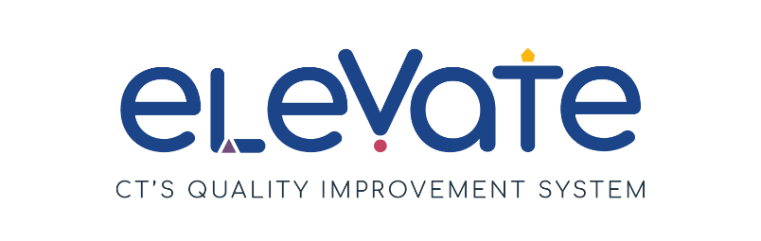
Build Your Team: Onboarding New Staff Checklist
Use this checklist to evaluate the onboarding of new staff in your program. For each item, place a check in the column that applies. Use “We’ve got this!” for items that are working well. Use “This is a work in progress” for your growth areas. After you complete the checklist, think about how your responses might point you to a place to start your quality improvement work.

 | We’ve got this! | This is a work in progress
My new staff member reviewed our:
  - Program’s curriculum
  - Staff Handbook
  - Family Handbook
  - CT health and safety licensing regulations
My new staff member understands the job description for their role.
If my new staff member is
multilingual, they have
onboarding materials in
their native language.
My new staff member is
enrolled in the Registry.
I check in with my new staff member weekly.
My new staff member is
paired with a mentor or
coach.
I check in with my new staff member’s mentor or coach weekly.
My new staff member knows
how to find resources to
support children’s learning.
My new staff member knows
how to find higher education
Coursework.
My new staff member knows
how to find OEC
scholarships to support
higher education
Coursework.

