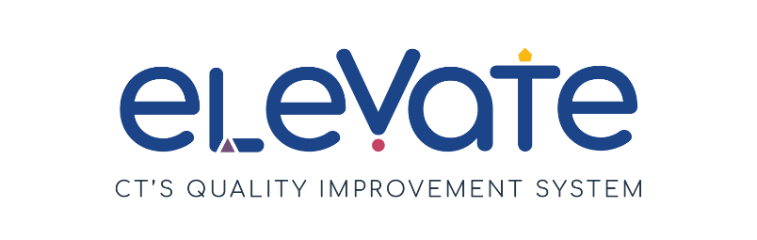
Manage Your Business Checklist
Use this checklist to evaluate your business strategies. For each item, place a check in the column that applies. Use “We’ve got this!” for items that are working well. Use “This is a work in progress” for your growth areas. After you complete the checklist, think about how your responses might point you to a place to start your quality improvement work.

 | We’ve got this! | This is a work in progress
We have a program
operating budget.
We review our program’s
operating budget monthly or
quarterly.
We use software to manage
billing and family payments.
Our business expenses are separate from any staff member’s personal expenses.
We have a clear policy for families about payment for care.
We market our business to
attract new families.
We have the technology we
need to reach our goals.
We have a plan for
classroom coverage when
staff are sick or unavailable.
We have Mission and Vision statements.
We connect with the
Women’s Business
Development Council for
business support.
We have a system for staff to
share feedback on program
management issues.
We take time to build positive relationships with individual staff members.
We organize team building
activities for staff to
connect with each other.
We stay up to date on early care and education policy through connections in CT and nationally.

