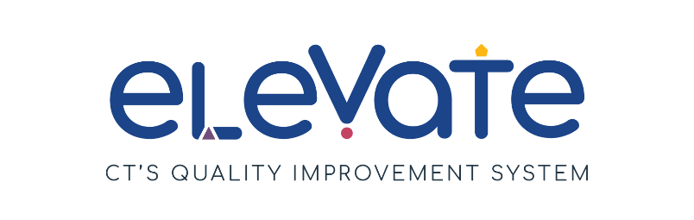

**Developing Program Plan**

The **Developing Program Plan** is for you to keep track of your continuous improvement process. You can use this form as a draft plan. You can also use it throughout the year as you work toward your goals.

**Getting Started**

All Program Plans include SMART Goals and plans to make them happen.

* Do you need to learn more about SMART Goals? Check out our resources [here](https://www.ctoec.org/elevate/create-program-plan/center-group-program-plan/).
* Don't know where to start? Read more about [Elevate Focus Areas](https://www.ctoec.org/elevate/focus-areas/).
* Want to learn more about Elevate? Learn more [here](https://www.ctoec.org/elevate/).

**Reflections**

Reflection is an important part of the continuous quality improvement process. Return to your Developing Program Plan often and consider:

Areas of strength and areas for growth

Feedback from your staff

Feedback from the families you serve

**Next Steps**

You can use your Developing Program Plan as a draft for the Elevate Program Plan on the [OEC Provider Portal](https://oec.service.ct.gov/provider360/s/mydashboard). Program Plans are submitted annually on the OEC 360 Provider Portal to achieve and maintain the Member+ Elevate Level of Engagement.

Need additional help thinking through your Developing Program Plan? Reach out to your [Service Navigator](https://www.ctoec.org/elevate/service-navigator/) today!

**Developing Program Plan**

Use the **Developing Program Plan** to track your SMART goals for the year ahead. Return to it often to reflect on action steps, challenges, and resources.

|  |  |
| --- | --- |
| **SMART Goal 1:** | |
| **Focus Area**   * ***Choose one*** | p Build your Team  p Connect with Families  p Enhance your Environment  p Manage your Business  p Support Child Development |
| **Action steps: What needs to happen to achieve the goal?**   * ***Use bullet points for each step. Avoid long sentences and paragraphs.*** | 1.  2.  3.  4.  5. |
| **Current Reality, Challenges, or Barriers**   * ***Choose all that apply*** | p Time needed away from caring for children  p Money needed to complete goal  p Staffing shortage  p Low enrollment  p Other reason: |
| **What resources are needed?**   * ***List the specific tools and resources you will use to reach your goal.*** |  |
| **Who will do this?**   * ***Having a specific person in the program responsible for the EPP, will help in reaching the goal.*** |  |
| **How are you tracking progress?**   * ***Set check-in points to help maintain progress.*** |  |

|  |  |
| --- | --- |
| **SMART Goal 2:** | |
| **Focus Area**   * ***Choose one*** | p Build your Team  p Connect with Families  p Enhance your Environment  p Manage your Business  p Support Child Development |
| **Action steps: What needs to happen to achieve the goal?**   * ***Use bullet points for each step. Avoid long sentences and paragraphs.*** | 1.  2.  3.  4.  5. |
| **Current Reality, Challenges, or Barriers**   * ***Choose all that apply*** | p Time needed away from caring for children  p Money needed to complete goal  p Staffing shortage  p Low enrollment  p Other reason: |
| **What resources are needed?**   * ***List the specific tools and resources you will use to reach your goal.*** |  |
| **Who will do this?**   * ***Having a specific person in the program responsible for the EPP, will help in reaching the goal.*** |  |
| **How are you tracking progress?**   * ***Set check-in points to help maintain progress.*** |  |

|  |  |
| --- | --- |
| **SMART Goal 3:** | |
| **Focus Area**   * ***Choose one*** | p Build your Team  p Connect with Families  p Enhance your Environment  p Manage your Business  p Support Child Development |
| **Action steps: What needs to happen to achieve the goal?**   * ***Use bullet points for each step. Avoid long sentences and paragraphs.*** | 1.  2.  3.  4.  5. |
| **Current Reality, Challenges, or Barriers**   * ***Choose all that apply*** | p Time needed away from caring for children  p Money needed to complete goal  p Staffing shortage  p Low enrollment  p Other reason: |
| **What resources are needed?**   * ***List the specific tools and resources you will use to reach your goal.*** |  |
| **Who will do this?**   * ***Having a specific person in the program responsible for the EPP, will help in reaching the goal.*** |  |
| **How are you tracking progress?**   * ***Set check-in points to help maintain progress.*** |  |