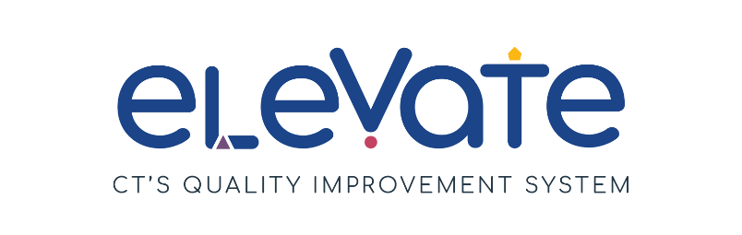

**SAMPLE Developing Program Plan**

**Center-based**

The **Developing Program Plan** is for you to keep track of your continuous improvement process. You can use this form as a draft plan. You can also use it throughout the year as you work toward your goals.

**Getting Started**

All Program Plans include SMART Goals and plans to make them happen.

* Do you need to learn more about SMART Goals? Check out our resources [here](https://www.ctoec.org/elevate/create-program-plan/center-group-program-plan/).
* Don't know where to start? Read more about [Elevate Focus Areas](https://www.ctoec.org/elevate/focus-areas/).
* Want to learn more about Elevate? Learn more [here](https://www.ctoec.org/elevate/).

**Reflections**

Reflection is an important part of the continuous quality improvement process. Return to your Developing Program Plan often and consider:

Areas of strength and areas for growth

Feedback from your staff

Feedback from the families you serve

**Next Steps**

You can use your Developing Program Plan as a draft for the Elevate Program Plan on the [OEC Provider Portal](https://oec.service.ct.gov/provider360/s/mydashboard). Program Plans are submitted annually on the OEC 360 Provider Portal to achieve and maintain the Member+ Elevate Level of Engagement.

Need additional help thinking through your Developing Program Plan? Reach out to your [Service Navigator](https://www.ctoec.org/elevate/service-navigator/) today!

**Developing Program Plan**

Use the **Developing Program Plan** to track your SMART goals for the year ahead. Return to it often to reflect on action steps, challenges, and resources.

|  |  |
| --- | --- |
| **SMART Goal 1:**  Within the next 2 months, we will develop an organized system of communication through the Sparkler App. Every teacher will find and distribute at least 1 developmental and/or play-based resource each month to send to families of the children in their classrooms. | |
| **Focus Area**   * ***Choose one*** | p Build your Team  x Connect with Families  p Enhance your Environment  p Manage your Business  p Support Child Development |
| **Action steps: What needs to happen to achieve the goal?**   * ***Use bullet points for each step. Avoid long sentences and paragraphs.*** | * We will receive training from a Sparkler facilitator on how to download and use the app. * Ensure all educators are comfortable utilizing the app and features needed to post and communicate with families. * Roll out the Sparkler app to families. Hold a training night for families with the Sparkler facilitator. * Ensure all families can access the app and begin implementation. * Support educators in making their first resource posts. * Encourage ongoing use of the app and support monthly postings. * Continue to explore app features and implement new items as we are able. |
| **Current Reality, Challenges, or Barriers**   * ***Choose all that apply*** | x Time needed away from caring for children  p Money needed to complete goal  p Staffing shortage  p Low enrollment  p Other reason: |
| **What resources are needed?**   * ***List the specific tools and resources you will use to reach your goal.*** | * Sparkler App * Training * Resources for parents |
| **Who will do this?**   * ***Having a specific person in the program responsible for the EPP, will help in reaching the goal.*** | Director and Assistant Director |
| **How are you tracking progress?**   * ***Set check-in points to help maintain progress.*** | * Keep a calendar of tasks for a timeline * Make a checklist of tasks that need to be completed |

|  |  |
| --- | --- |
| **SMART Goal 2:**  In the next two months we will work to build and maintain enrollment by increasing social media posts and attending community events to attract more families. We aim to see 10% increase in enrollment within 6-12 months of implementing these efforts. | |
| **Focus Area**   * ***Choose one*** | p Build your Team  p Connect with Families  p Enhance your Environment  x Manage your Business  p Support Child Development |
| **Action steps: What needs to happen to achieve the goal?**   * ***Use bullet points for each step. Avoid long sentences and paragraphs.*** | * Build a social media calendar plan and content to post over the next six months on a weekly / bi-weekly basis * Inquire about community events happening over the next 6-9 months and register for table space if able * Create enrollment flyers to post at local stores and community spaces * Ask parents to help spread the word on social media by sharing posts or sharing flyers in their neighborhoods * Continue to post and update social media and community bulletin boards weekly/monthly as needed * Add a question on the enrollment paperwork: How did you learn about our program? To help gather data around marketing strategies. |
| **Current Reality, Challenges, or Barriers**   * ***Choose all that apply*** | x Time needed away from caring for children  x Money needed to complete goal  p Staffing shortage  x Low enrollment  p Other reason: |
| **What resources are needed?**   * ***List the specific tools and resources you will use to reach your goal.*** | * Social media accounts for the program: Instagram, Facebook, LinkedIn * Access to local / community events calendars for our town and surrounding towns * Some financial support to create the flyers and bulk printing. |
| **Who will do this?**   * ***Having a specific person in the program responsible for the EPP, will help in reaching the goal.*** | Director |
| **How are you tracking progress?**   * ***Set check-in points to help maintain progress.*** | * Calendar of events * Checklist * Monthly social media post tracking |

|  |  |
| --- | --- |
| **SMART Goal 3:**  Within the next six months we will identify four classrooms that will use the CT ELDS to plan their weekly lesson plans to ensure their curriculum is meeting the developmental needs of all children in their classroom. | |
| **Focus Area**   * ***Choose one*** | p Build your Team  p Connect with Families  p Enhance your Environment  p Manage your Business  x Support Child Development |
| **Action steps: What needs to happen to achieve the goal?**   * ***Use bullet points for each step. Avoid long sentences and paragraphs.*** | * Identify four classrooms that will receive CT ELDS training * Set up initial training for CT ELDS for the designated classrooms * Set up a follow-up training series for continued learning around the CT ELDS * When ready to implement CT ELDS into lesson planning, Director will complete Plan reviews and provide guidance as needed. * Utilize the cycle of intentional teaching for continued planning * Conduct staff PLC sessions for ongoing learning and support |
| **Current Reality, Challenges, or Barriers**   * ***Choose all that apply*** | x Time needed away from caring for children  p Money needed to complete goal  x Staffing shortage  p Low enrollment  x Other reason: With turnaround of staffing, full implementation could take some additional time. |
| **What resources are needed?**   * ***List the specific tools and resources you will use to reach your goal.*** | * CT ELDS materials * Trainers * Staff coverage for training times |
| **Who will do this?**   * ***Having a specific person in the program responsible for the EPP, will help in reaching the goal.*** | Director and Assistant Director |
| **How are you tracking progress?**   * ***Set check-in points to help maintain progress.*** | * Calendar of training events * Checklist of tasks that need to happen * Agendas for PLC meetings to track progress * Director classroom observations to track implementation progress and future training needs |