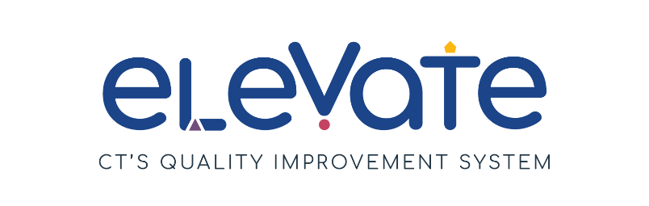

**SAMPLE Developing Program Plan**

**Family Child Care**

The **Developing Program Plan** is for you to keep track of your continuous improvement process. You can use this form as a draft plan. You can also use it throughout the year as you work toward your goals.

**Getting Started**

All Program Plans include SMART Goals and plans to make them happen.

* Do you need to learn more about SMART Goals? Check out our resources [here](https://www.ctoec.org/elevate/create-program-plan/center-group-program-plan/).
* Don't know where to start? Read more about [Elevate Focus Areas](https://www.ctoec.org/elevate/focus-areas/).
* Want to learn more about Elevate? Learn more [here](https://www.ctoec.org/elevate/).

**Reflections**

Reflection is an important part of the continuous quality improvement process. Return to your Developing Program Plan often and consider:

Areas of strength and areas for growth

Feedback from your staff

Feedback from the families you serve

**Next Steps**

You can use your Developing Program Plan as a draft for the Elevate Program Plan on the [OEC Provider Portal](https://oec.service.ct.gov/provider360/s/mydashboard). Program Plans are submitted annually on the OEC 360 Provider Portal to achieve and maintain the Member+ Elevate Level of Engagement.

Need additional help thinking through your Developing Program Plan? Reach out to your [Service Navigator](https://www.ctoec.org/elevate/service-navigator/) today!

**Developing Program Plan**

Use the **Developing Program Plan** to track your SMART goals for the year ahead. Return to it often to reflect on action steps, challenges, and resources.

|  |  |
| --- | --- |
| **SMART Goal 1:**  I will create a resource bulletin board, within the next two months, where I will share resources on a monthly and / or quarterly basis, that are relevant for families on various topics including: developmental milestones, infant/toddler development, social-emotional development, and community-based resources available for children and families. | |
| **Focus Area**   * ***Choose one*** | p Build your Team  x Connect with Families  p Enhance your Environment  p Manage your Business  p Support Child Development |
| **Action steps: What needs to happen to achieve the goal?**   * ***Use bullet points for each step. Avoid long sentences and paragraphs.*** | * Create a space in my home for a bulletin board * Purchase a bulletin board, double sided tape, and envelopes/folders to display resources * Explore community resources I would like to share * Gather OEC resources I would like to share * Send a flyer home to families introducing the resource center. * Each month review resources for currency and update as needed * As part of enrollment paperwork, ask caregivers what types of resources might support them. * Complete monthly check-ins during drop off/pick-up times to remind caregivers of resources and ask if they are finding them beneficial. |
| **Current Reality, Challenges, or Barriers**   * ***Choose all that apply*** | x Time needed away from caring for children  x Money needed to complete goal  p Staffing shortage  p Low enrollment  p Other reason: |
| **What resources are needed?**   * ***List the specific tools and resources you will use to reach your goal.*** | * Bulletin board, tape, envelope/folders * OEC resources * Community resources |
| **Who will do this?**   * ***Having a specific person in the program responsible for the EPP, will help in reaching the goal.*** | Snow White |
| **How are you tracking progress?**   * ***Set check-in points to help maintain progress.*** | * Keep a checklist of community resources I have explored and need to explore * Keep a checklist of OEC resources I have provided * Calendar to track when the board is updated |

|  |  |
| --- | --- |
| **SMART Goal 2:**  I will increase program enrollment to reach maximum capacity within the next six months by increasing my use of social media platforms in the next two months. This will be updated at least two times a year or as openings become available. | |
| **Focus Area**   * ***Choose one*** | p Build your Team  p Connect with Families  p Enhance your Environment  x Manage your Business  p Support Child Development |
| **Action steps: What needs to happen to achieve the goal?**   * ***Use bullet points for each step. Avoid long sentences and paragraphs.*** | * Increase social media posts over the next two months * Make posts colorful and engaging to draw attention with an updated post each week * Ask parents to help spread the word on social media by sharing posts * Continue to post and update social media weekly/monthly as needed * Ask potential families how they learned about my program. |
| **Current Reality, Challenges, or Barriers**   * ***Choose all that apply*** | x Time needed away from caring for children  p Money needed to complete goal  p Staffing shortage  x Low enrollment  p Other reason: |
| **What resources are needed?**   * ***List the specific tools and resources you will use to reach your goal.*** | * Social media accounts for the program: Instagram, Facebook, LinkedIn * Access to local / community social media sites |
| **Who will do this?**   * ***Having a specific person in the program responsible for the EPP, will help in reaching the goal.*** | Snow White |
| **How are you tracking progress?**   * ***Set check-in points to help maintain progress.*** | * Monthly social media post tracking |

|  |  |
| --- | --- |
| **SMART Goal 3:**  I will review the CT ELDS on a monthly basis to ensure my curriculum aligns with the standards and assessments for all the ages and stages specific to the children in my care and will update lesson plans as needed. | |
| **Focus Area**   * ***Choose one*** | p Build your Team  p Connect with Families  p Enhance your Environment  p Manage your Business  x Support Child Development |
| **Action steps: What needs to happen to achieve the goal?**   * ***Use bullet points for each step. Avoid long sentences and paragraphs.*** | * Complete training on CT ELDS offered through the OEC PD page * Implement CT ELDS in my curriculum planning * Adjust plans as need to meet the needs of the children I serve * Reach out to SFCCN and my community of FCC providers to find a community of support for CT ELDS implementation * Attend any training that will strengthen my skills * Complete child observations and adjust lesson plans to meet child developmental needs. * Continue to update plans based on developmental appropriateness |
| **Current Reality, Challenges, or Barriers**   * ***Choose all that apply*** | x Time needed away from caring for children  p Money needed to complete goal  p Staffing shortage  p Low enrollment  p Other reason: |
| **What resources are needed?**   * ***List the specific tools and resources you will use to reach your goal.*** | * CT ELDS materials * Trainers * CT ELDS training through OEC Training Calendar |
| **Who will do this?**   * ***Having a specific person in the program responsible for the EPP, will help in reaching the goal.*** | Snow White |
| **How are you tracking progress?**   * ***Set check-in points to help maintain progress.*** | * Calendar of trainings * Checklist of implementation * Ongoing child observation |